MullinStack Project Weekly Digest

horizontal line

# CEIP with no internet, better I turn it off!

And give back some free memory...



By MullinStack Team Sept 2019

Community, a short topic but so important having in count because is part of our work the **“resources optimizing”** which in turn get more importance with the cloud services where the companies **charge us for the use** of it.

Recently we have created a couple of SQL Server servers into the cloud, version 2016 Standard Edition but when I take a look at the processes running into the servers, I see particularly 3 processes that get my attention because I really don’t know anything about it:

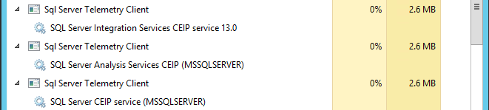

These processes belong to a Microsoft program called **“Customer Experience Improvements”**

These are designed to gather information about Hardware use and how the users use the software, in this case specifically **SQL Server, Analysis and Integration Services**.

Reviewing the services through the SQL Configuration Manager Console, you won’t see them here.

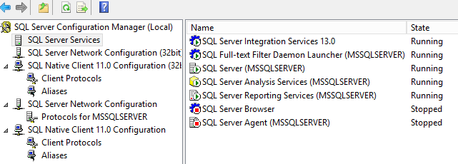

But if I go to take a look at the Operative System services, through the Windows Services Manager Console, we found this:

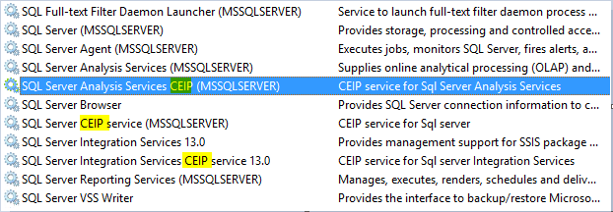

From here, is possible to see the services which **“start”** those processes that I saw with the Task Manager.

The servers won’t have internet access and that means the main purpose, sharing information to Microsoft won’t work. Another point could be don’t agree with sharing information about our infrastructure use to Microsoft but anyway we have the plus getting back resources like memory… it is better to turn them off and disable them, to do that we need to follow some steps:

1. Deactivate the services:
   1. SQL Server Analysis Services CEIP Service
   2. SQL Server CEIP Service
   3. SQL Server Integration Services CEIP Service
2. Set the CEIP keys to cero (image below):
   1. HKLM:\SOFTWARE\Microsoft\Microsoft SQL Server
   2. HKLM:\SOFTWARE\Wow6432Node\Microsoft\Microsoft SQL Server

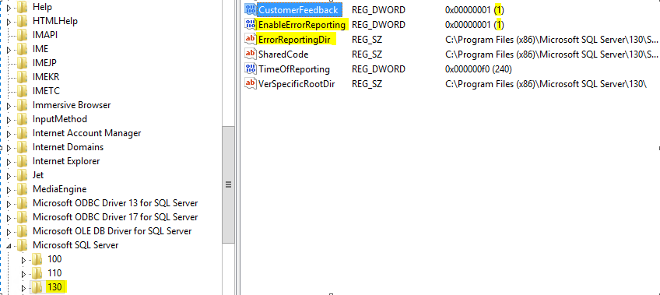

All these changes to get them turned off , we can find them within the **Powershell** script from the GitHub link at the references:

[SQL Server CEIP Services Disable](https://github.com/jotaccruz/SQLServer-CEIP-Services)

**References:**

<https://blog.dbi-services.com/sql-server-tips-deactivate-the-customer-experience-improvement-program-ceip/>

|  |
| --- |
| [**LEER MAS EN NUESTRO SITIO WEB**](http://www.mullinstack.com/) |



MullinStack Project.

El Salvador, San Salvador, CA